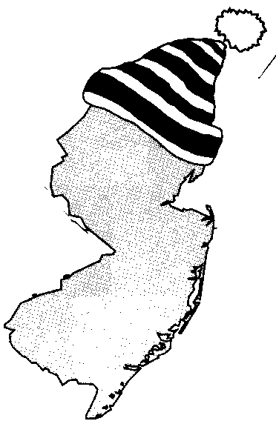
New Jersey Citizen Action
Oil Group

PRESS RELEASE

Fight Back Against Cold Temperatures—Stay Warm for Less This Winter!

For more information please call: For immediate release:
Wende Nachman: 856-966-3095 ext.202 October 29, 2008

New Jersey –The temperatures outside are starting to drop and, fortunately, the oil prices seem to be dropping as well. In fact, current crude oil prices are around $62 a barrel (down from over $140 a barrel just a few months ago) and New Jersey consumers are paying an average of $2.70 per gallon. Just don’t get too comfortable! Analysts are predicting that oil could soon be on the rise again; reaching above $4.20 per gallon this winter.

Consumers can help protect themselves by joining New Jersey Citizen Action Oil Group. The Oil Group uses bulk purchasing power to negotiate lower prices so consumers can save hundreds of dollars a year on their home heating oil. In fact, last year most of their members saved between $300 and $600 dollars. “Members of the Oil Group feel confident that not only are they getting a bargain on their price of oil, but they are also taking a stand in the fight for lower oil prices,” stated Wende Nachman, New Jersey Citizen Action Oil Group Director.

New Jersey Citizen Action Oil Group is a member based organization with well established, full service oil companies. When compared to retail prices, Oil Group members benefit from substantial savings. Along with a discount on oil, our suppliers provide additional services such as: budget billing, automatic fill, service contracts, tank insurance and price caps in some areas. The program is not limited to homeowners or tenants; churches, businesses, non-profit associations and apartment owners can also join

New Jersey Citizen Action is the state’s largest independent citizen watchdog organization, representing 70,000 family members and 100 affiliated labor, tenant, community, faith bases, civil rights, environmental, senior and women’s organizations.

Interested residents can also contact the Oil Group at 1-800-464-8465 or visit us on the web at www.njcaoilgroup.com.

Arrangements can be made for interviews with Oil Group members.

