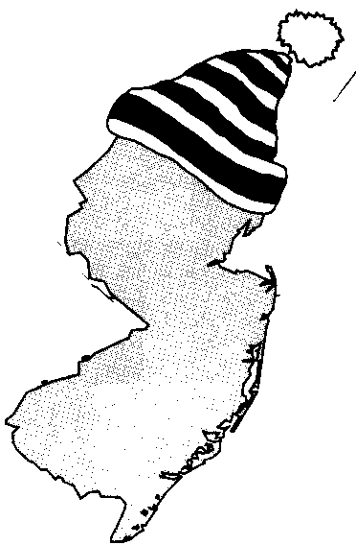
New Jersey Citizen Action
Oil Group

PRESS RELEASE

Beware of the Heating Oil Lock-In!

For more information please call: For immediate release:
Wende Nachman: 856-966-3095 ext.202 December 11, 2008

New Jersey –Even though oil prices have fallen to a three year low, many unfortunate consumers are stuck paying over $5.00 per gallon. When oil peaked at $5.00 per gallon this past summer, many consumers panicked at the thought of paying even higher prices this winter. Adding to that fear were the experts who were forecasting that oil would reach $6.00 per gallon by early 2009.

Savvy consumers tried to protect themselves by locking into a price. Unfortunately, as those people are finding out, lock-ins are a risky business. If the market drops, you end up paying more for the oil than it is worth. The risk this year is a mistake worth $3.00 per gallon now that oil is hovering around $2.00 per gallon!

One way to minimize the risk of lock-ins is by joining New Jersey Citizen Action Oil Group. The Oil Group uses bulk purchasing power to negotiate discount prices with their suppliers so that you don’t have to shop around or enter into potentially expensive contracts. Joining the Oil Group allows you to float with the market while protecting you from inflated profit margins.

“Our members don’t have to play the guessing game when it comes to heating oil decisions because they know they are always going to get the best price and service from our dealers,” stated Wende Nachman, New Jersey Citizen Action Oil Group Director. “In fact, many Oil Group members saw savings as high as $600 over the course of the last heating season,” she added.

New Jersey Citizen Action Oil Group is open to all New Jersey residents and businesses. Along with a discount on oil, suppliers provide a range of options such as budget billing, 20 day billing, COD, automatic or will-call fill, service contracts and tank insurance.

Interested residents can also contact the Oil Group at 1-800-464-8465 or visit us on the web at www.njcaoilgroup.com.

Arrangements can be made for interviews with Oil Group members.

