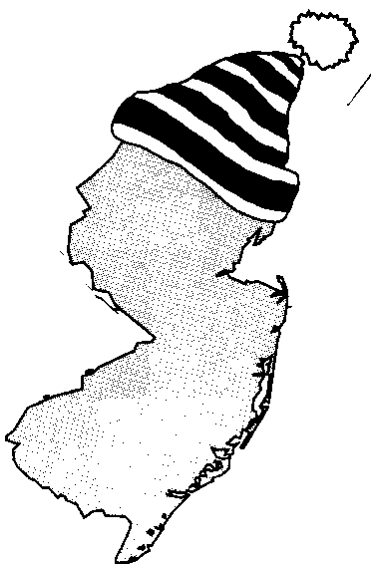
New Jersey Citizen Action
Oil Group

PRESS RELEASE

Fight Back Against Cold Temperatures and High Heating Oil Prices

For more information please call: For immediate release:
Wende Nachman: 856-966-3095 ext.202 December 6, 2007

New Jersey – With the first snowfall of the season upon us, Old Man Winter has sent most of New Jersey into an artic chill. The temperatures outside are plummeting, but heating oil consumers don’t have to be left out in the cold. New Jersey Citizen Action Oil Group offers a program to keep New Jersey residents warm for less! We use bulk purchasing power to negotiate lower prices so consumers can save hundreds of dollars a year on their home heating oil.

New Jersey Citizen Action is the state’s largest independent citizen watchdog organization, representing 70,000 family members and 100 affiliated labor, tenant, community, faith bases, civil rights, environmental, senior and women’s organizations.

Interested residents can also contact the Oil Group at 1-800-464-8465 or visit us on the web at www.njcaoilgroup.com.

Arrangements can be made for interviews with Oil Group members.

