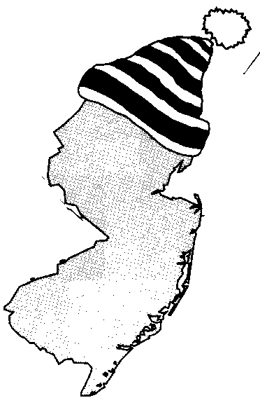
New Jersey Citizen Action
Oil Group

PRESS RELEASE

It’s Time to Winterize Your Home…for LESS!

For more information please call: For immediate release:
Wende Nachman: 856-966-3095 ext.202 October 4, 2007

New Jersey – Crude oil prices are at a record high, peaking at over $84 a barrel. In fact, according to the national Energy Assistance Directors’ Association, the average oil heat consumer is expected to pay approximately $1,184 this year, up 28% from last year. However, if you properly prepare your home for the chilly temperatures of the winter, you can put some of that money back in your pocket.

If you feel a shiver each time you open your utility bill, follow these simple no-cost ways to stay warm for less:

- Be sure to take advantage of New Jersey Citizen Action Oil Group. We offer a program designed with New Jersey residents in mind—we help to fight the high cost of fuel, and most members save hundreds of dollars a year on their home heating oil.
- Turn down your thermostat to 68 degrees. For every degree you lower you heat in the 60-degree to 70-degree range, you’ll save an average of 3% on heating costs.
- Close off heating ducts to unused rooms, or unoccupied areas of your home. This helps to confine heat to the areas of your home that you’re using.
- Replace or clean furnace filters once a month. Dirty filters restrict airflow and increase energy use. Proper maintenance of your furnace can save up to 5% on heating costs.
- Use cold water when washing clothes. About 16% of an average home energy bill goes just for heating water.
- Let the sun in. Open drapes and shades on the sunny side of your house to help warm your home during the day.
- Remove window air conditioner units for the winter. If you have a window air conditioning unit, remove it to prevent heat from escaping. If it can’t be removed, buy a cover to prevent drafts.

New Jersey Citizen Action Oil Group uses bulk purchasing power to negotiate lower prices with well established, full service oil companies. When compared to retail prices (please see chart), Oil Group members benefit from substantial savings. “I’ve been a member of the NJCA Oil Group for almost 10 years - and I've saved significantly on my oil bill during this time. In fact, the savings on your first oil delivery more then pays for the membership fee. This is the best deal in town”, stated Richard Rapiti of Essex County. Along with a discount on oil, our suppliers provide additional services such as: budget billing, automatic fill, service contracts, tank insurance and price caps in some areas. The program is not limited to homeowners or tenants; churches, businesses, non-profit associations and apartment owners can also reap substantial savings

New Jersey Citizen Action is the state’s largest independent citizen watchdog organization, representing 70,000 family members and 100 affiliated labor, tenant, community, faith bases, civil rights, environmental, senior and women’s organizations.

Interested residents can also contact the Oil Group at 1-800-464-8465 or visit us on the web at www.njcaoilgroup.com.

Arrangements can be made for interviews with Oil Group members.

