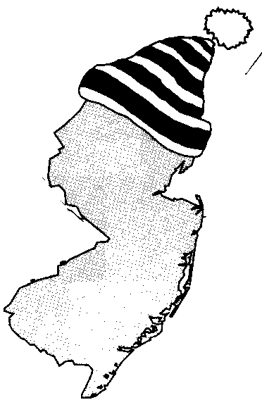
New Jersey Citizen Action
Oil Group

PRESS RELEASE

For more information, please call: For immediate release:
Wende Nachman: 856-966-3095, ext. 202 November 28, 2007

Don’t Get Left Out in the Cold

New Jersey – The temperature has dropped, but oil prices continue to climb. In fact, current crude oil prices are nearing a record $100 per barrel and New Jersey consumers are paying an average of $3.21 per gallon. According to the Energy Information Association, households in the northeast can expect to pay approximately 66 cents more per gallon than last year!

The record high prices and increasingly volatile market are hurting everyone. There are no attractive deals to offer when securing the oil alone is costing suppliers more than $2.65 per gallon. “The reality is that heating oil is going to be unaffordable to many New Jersey residents,” stated Wende Nachman, Director of New Jersey Citizen Action Oil Group. It is especially hard for the elderly consumers on a fixed budget to make the choice of heating their home or buying food or medicine

This is startling news; however, there is some relief for New Jersey consumers. New Jersey Citizen Action Oil Group uses its bulk purchasing power to negotiate lower prices with well established, full service oil companies. Along with a 10%-30% discount on oil, their suppliers provide additional services such as: budget billing, automatic fill, service contracts, tank insurance and price caps in some areas. Last year, Oil Group members saved $200 - $400 over the course of the season. Interested consumers can contact the Oil Group at 1-800-464-8465 or visit us on the web at www.njcaoilgroup.com.

New Jersey Citizen Action is the state’s largest independent citizen watchdog organization representing 70,000 individual members and over 100 affiliated labor, tenant, community, faith bases, civil rights, environmental, senior and women’s organizations.

Arrangements can be made for interviews with Oil Group members.

