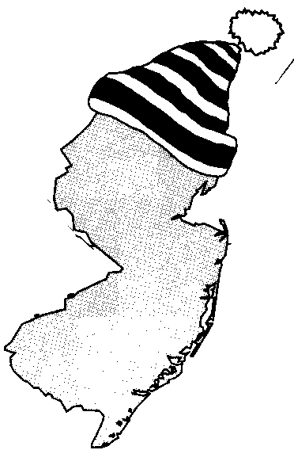
New Jersey Citizen Action
Oil Group

PRESS RELEASE

Fight Back Against Cold Temperatures and High Heating Oil Prices

For more information please call: For immediate release:
Wende Nachman: 856-966-3095 ext.202 January 19, 2007

New Jersey – A frigid blast from Old Man Winter has sent most of New Jersey into an artic chill. The temperatures outside are plummeting, but heating oil consumers don’t have to be left out in the cold. New Jersey Citizen Action Oil Group offers a program to keep New Jersey residents warm for less! We use bulk purchasing power to negotiate lower prices so consumers can save hundreds of dollars a year on their home heating oil.

During the colder months, when consumers are getting more oil deliveries, sticker shock often forces them to re-evaluate their energy usage. “Members of the Oil Group feel confident that not only are they getting a bargain on their price of oil, but they are also taking a stand in the fight for lower oil prices,” stated Wende Nachman, New Jersey Citizen Action Oil Group Director.

New Jersey Citizen Action Oil Group is a member based organization with well established, full service oil companies. When compared to retail prices, Oil Group members benefit from substantial savings. “I’ve been a part of the Oil Group since 1994 and I benefit from substantial savings year after year,” stated Rich Rapiti of Essex County. Along with a discount on oil, our suppliers provide additional services such as: budget billing, automatic fill, service contracts, tank insurance and price caps in some areas. The program is not limited to homeowners or tenants; churches, businesses, non-profit associations and apartment owners can also reap substantial savings.

New Jersey Citizen Action is the state’s largest independent citizen watchdog organization, representing 70,000 family members and 100 affiliated labor, tenant, community, faith bases, civil rights, environmental, senior and women’s organizations.

Interested residents can also contact the Oil Group at 1-800-464-8465 or visit us on the web at www.njcaoilgroup.com.

Arrangements can be made for interviews with Oil Group members.

