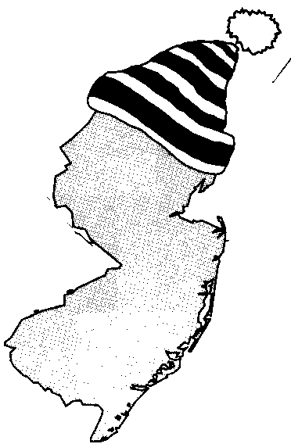
New Jersey Citizen Action
Oil Group

PRESS RELEASE

Seek Relief from High Heating Bills

For more information please call: For immediate release:
Wende Nachman: 856-966-3095 ext.202 December 12, 2007

New Jersey – With the first snowfall of the season upon us, many New Jersey residents are finding themselves in a desperate situation. Most families in this state live paycheck to paycheck and can’t afford the 20% increase in home heating costs this year. A minimum delivery of 150 gallons of heating oil costs over $500; forcing people to make a difficult choice between heating their home and purchasing medicine or food. However, help for New Jersey residents is available, you just need to know where to turn.

New Jersey Citizen Action Oil Group— New Jersey Citizen Action Oil Group uses its bulk purchasing power to negotiate lower prices with well established, full service oil companies. Along with a 10%-30% discount on oil, our suppliers provide additional services that include: budget billing, automatic fill, service contracts, tank insurance and price caps in most areas. Last year, Oil Group members saved $200 - $400 over the course of the season. Interested consumers can contact the Oil Group at 1-800-464-8465 or visit them on the web at www.njcaoilgroup.com.

Citizen’s Energy— In partnership with CITGO, Citizens Energy works with thousands of oil heat dealers and local fuel assistance agencies in 16 states (including NJ) to provide deliveries of home heating oil to those in need. This year the Oil Heat Program will provide eligible families a one-time FREE delivery of 100 gallons of home heating oil. To qualify, you must apply by February 29, 2008. Call 1-877-JOE-4-OIL (1-877-563-4645) or visit them on the web at
http://www.citizensenergy.com/english/pages/13/individual-households.

The Low Income Home Energy Assistance Program (LIHEAP)—LIHEAP helps low-income people pay their winter heating bills. You may qualify even if your heat is included in the rent you pay each month. The program usually runs from November 1 through March 31. The LIHEAP site is at www.acf.hhs.gov/programs/liheap.

The Universal Service Fund (USF)—USF helps make energy bills more affordable for low-income customers. If you're eligible, USF can lower the amount you have to pay for your gas and electric bills. USF accepts applications all year. You can apply for both LIHEAP and USF with one application and may be eligible for both. To apply, call 1-800-510-3102 or visit www.energyassistance.nj.gov.

NJ Lifeline Credit Program—If you are 65 years old or 18 years or older and receiving Social Security because you are disabled, Lifeline may be able to give you a $225 credit every year to help pay your gas and electric bills. Income guidelines change every year in January, so find out if you qualify by calling 1-800-792-9745 or visit www.state.nj.us/health/forms/ap-2.dot. Their mailing address is: NJ Lifeline, PO Box 714, Trenton NJ 08625-0714.

NJ Shares—NJ Shares helps people going through a short-term financial crisis. To qualify, you must show a history of paying your bills on time and that something has happened that keeps you from paying now. If you receive LIHEAP or USF, you are not eligible. Once approved, you can get up to $250 to pay your gas or electric bills. To apply, call 1-866-NJSHARES (1-866-657-4273) or visit www.njshares.org.

New Jersey Comfort Partners—If you are a low-income household and would like to lower your gas and electric bills by learning more about efficiency, New Jersey Comfort Partners can help you. Call 1-888-773-8326 or visit their site at www.njcleanenergy.com/html/1residential/4_comfort_partners.html.
______________________________________________________________________________

New Jersey Citizen Action is the state’s largest independent citizen watchdog organization, representing 70,000 family members and 100 affiliated labor, tenant, community, faith bases, civil rights, environmental, senior and women’s organizations.

Arrangements can be made for interviews with Oil Group members.

